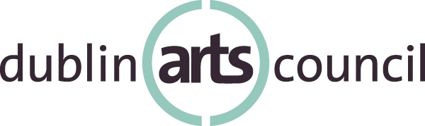
Community Art Grants
Final Report Guidelines 2022

The purpose of the final report is to summarize the work done under the grant received from Dublin Arts Council for 2022. Final reports are due by Thursday, February 9, 2023 by 5 p.m. The report should document how the organization spent funds and should include a detailed description of activities, including attendance figures.

Please include support materials; examples of publications/collateral and/or photos that demonstrate the use of Dublin Arts Council logo or verbal/written credit of Dublin Arts Council's support.
Failure to submit the grant follow-up report in a timely and complete manner could result in a disapproval of future grant applications.

Please begin your report with the following general information, and continue by responding to the prompts below. Your final report package will include the project activities narrative, support materials and an income and expense statement, as outlined in prompt #6.

Final Report Prompts:

Name of Organization:

Grant Amount:

Mailing Address:

Website:

Contact Person/Title/Email/Telephone:

Alternate Contact Person/Title/Email/Telephone:

- Please explain how funding from Dublin Arts Council influenced your organization's ability to fulfill its mission.

- Please give a brief overview of how your organization fulfilled the projected goals of the organization/project outlined in your grant application.

- Please describe one or two outcomes from the funded project that you view as great successes and why.

- Please include an example of your evaluation instrument(s).
- If applicable, please share a story or an anecdote from a participant or audience member who responded in some way to the funded activity.
- Please provide an itemized final actual income and expense statement.

- Please include any relevant image(s) of the project that may be shared on Dublin Arts Council’s website for promotional purposes.

Submission Process:

Submit a completed final report, including support materials:

- By mail: Dublin Arts Council, 7125 Riverside Drive, Dublin, Ohio 43016; Attn: Dr. David Guion

- Or by email: Katy Marque, Education & Development Manager at marque@dublinarts.org

Final reports must be received by no later than Thursday, Feb. 9, 2023 by 5 p.m.
No exceptions.

