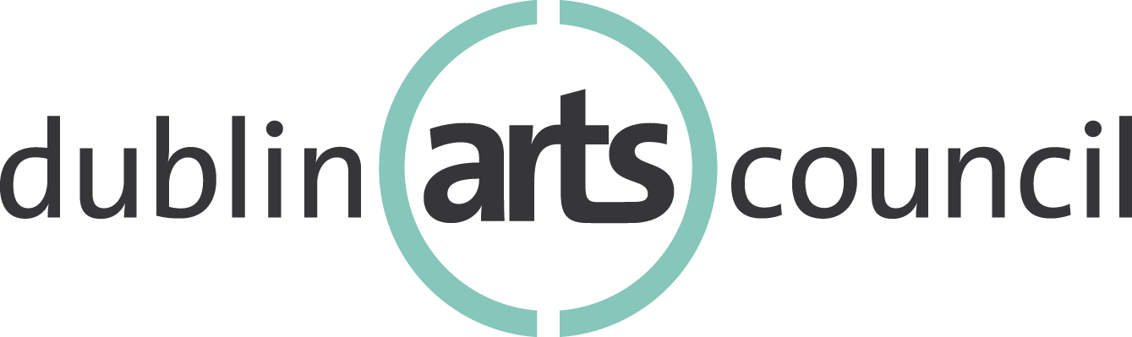
Community Arts Grant Program
2022 Application Form

Organization Information

Name of Organization:
Address:
Website:
Nonprofit? (Yes or no)
Tax-exempt? (Yes or no)
Contact Person
Title/Email/Telephone
Alterative Contact Person
Title/Email/Telephone

About Your Organization

Provide your organization’s mission statement (350 words max):

Brief history of the organization (1,000 words max):

About Your Project
Project Overview:

Title of Project: Amount Requested:

Project Start Date: Project End Date:

Statistical Information:

Personnel Data – Please indicate the # of personnel who will be involved in this project.

Number of staff:

Number of board members:

Number of contracted personnel (not artists):

Number of volunteers:

Total number of personnel involved (total the above):

Artist Data – Please indicate the # of artists who will be involved in this project.

Total number of artists participating in the project:

Audience Data – Please indicate the # of individuals who will benefit from your proposed project through in-person and/or virtual participation.

# of live audience/in-person participants:

# of virtual audience participants (web, radio, TV, etc.):

Total audience (live + virtual):

Audience Demographics – Using the audience data above, please estimate the number of audience members (live + virtual participants) in the following racial/ethnic categories:

American Indian/Alaska Natives:

Asian:

Black/African American:

Hispanic/Latinx:

Native Hawaiian/Pacific Islander:

Appalachian:

Project Narrative:

Project Summary: Please provide a clear, detailed description of your project(s) for which you are seeking funding. Your description should answer who, what, when, where and why. (3,000 words max):

Project Goals: Please list the goals of the project, and how these goals align with Dublin Arts Council's mission and funding criteria. Please see DAC Grant Procedures for details. (1,500 words max):

Project Implementation: Describe how the project will be implemented. What are the qualifications of the individuals responsible for shaping and executing the project? What is your timeline? What is your marketing and evaluation plan? (1,500 words max)

Project Impact & Accessibility: Describe the impact the project will have on target audience/community as related to your project goals. How will your organization strive to make the project accessible to diverse audiences? (1,500 words max)

Organizational Impact: How has COVID-19 impacted your organization, your financial health and programming? How will your organization adapt the project in the event that COVID-19 prevents in-person gatherings? (1,500 words max)

Financial Information

Income & Expense Statement: Please provide an Income and Expense statement (as a separate document) comparing the current fiscal year budget with the prior fiscal year actual. Please see example template. For any significant changes (example, greater than 20%) between the current fiscal year and prior fiscal year, please explain circumstances.

Balance Sheet: Please provide a Balance Sheet (as a separate document) for the year-end date of the most recent completed fiscal year. Please see example template.

In-Kind Support: Please provide a listing of In-kind support if applicable. May be submitted as a separate document.

Supporting Documentation Checklist

Please include the following attachments along with this application form.

- Publicity/Marketing examples
- Fundraising examples/mailers
- Staff bios
- Income and expense statement
- Balance sheet
- List of in-kind support
- Sample evaluation tool

Submission Process

Submit a completed application form and supporting documentation:

- By mail: Dublin Arts Council, 7125 Riverside Drive, Dublin, Ohio 43016; Attn: Dr. David Guion

- Or by email: Katy Marque, Education & Development Manager at marque@dublinarts.org.

Requested materials must be received by Thursday, November 18, 2021 by 5 p.m.
No exceptions.

