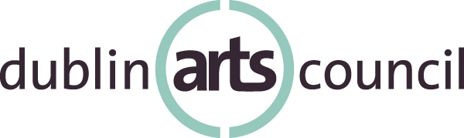
7125 Riverside Dr., Dublin, Ohio 43016
614/889-7444 • www.dublinarts.org

Dublin Arts Council
Community Art Grants
Final Report Guidelines 2016

The purpose of the final report is to summarize the work done under the grant received from Dublin Arts Council for 2016. Final reports are due by February 28, 2017. The report should document how the organization spent funds and should include a detailed description of activities, including attendance figures.
Please include support materials; examples of publications/collateral and/or photos that demonstrate the use of Dublin Arts Council logo or verbal/written credit of Dublin Arts Council's support.
Failure to submit the grant follow-up report in a timely and complete manner could result in a disapproval of future grant applications.
Please begin your report with the following general information, and continue by responding to the prompts below. Your final report package will include the project activities narrative, support materials and an income and expense statement, as outlined in prompt #8.

Name of Organization:
Grant Amount:
Mailing Address:
Website:
Contact Person/Title/Email/Telephone:
Alternate Contact Person/Title/Email/Telephone:

- Please explain how funding from Dublin Arts Council influenced your organization's ability to fulfill its mission.

- Please give a brief overview of how your organization fulfilled the projected goals of the organization/project outlined in your grant application. Address factors that facilitated or impeded your organization's ability to meet the projected goals.

- Please describe one or two outcomes from the funded project that you view as great successes and why.

- In relation to the funded project, what worked well and what needed greater attention? Please provide any new best practices from which your organization benefitted.

- How will your organization use information gathered from last year's funded projects to inform current programming?

- Please include an example of your evaluation instrument(s), a brief summary of the evaluation process and data analysis with this final report. How will your organization utilize this data or how will this data contribute to other Community Arts Grants applicants?

- If applicable, please share a story or an anecdote from a participant or audience member about a funded activity or about an unanticipated success that resulted from the work of this grant.

- Please provide an itemized final actual income and expense statement with a brief written explanation of significant variance from your projected budget.

Final reports, including support materials, must be mailed
(postmarked no later than Feb. 28, 2017)
or delivered by 5pm Feb. 28, 2017 to:
Dublin Arts Council
7125 Riverside Dr.
Dublin, Ohio 43016
Attn. Dr. Gretchen McIntosh

Dublin Arts Council engages the community, cultivates creativity and fosters life-long learning through the arts.

